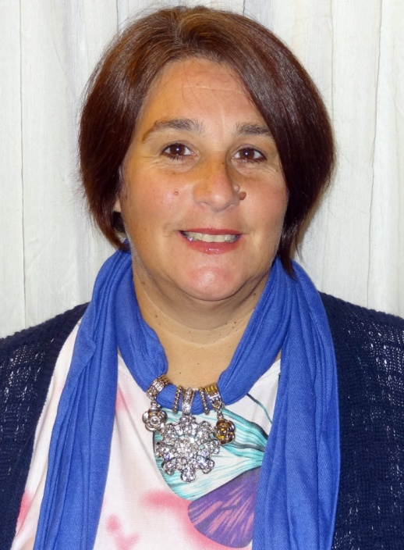

**Vote for Me**

I am seeking your support in being elected Provincial President of our Union.

I have received endorsement from the following Regional Vice Presidents: Pam Mancuso, Region 1 (North), Andy Summers, Region 3 (GTA) and Karen Bertrand, Region 5 (West), as well as from the First Vice-President candidate James Murray.

I bring passion, enthusiasm, hard work and a fresh new perspective to the position of ONA President.

I strongly feel that ONA leaders and all of its members need to be heard and supported - and I promise to make this my key focus as your Provincial President.

As Vice-President, I have always worked hard to improve our working conditions and vow to continue that fight as your President.

**For More Info:**

<http://electdianneleclair.weebly.com/>

[Email: electdianneleclair@gmail.com](mailto:electdianneleclair@gmail.com?subject=Campaign%20Questions)

**Voice Mail:** (416) 964-1979

Toll Free: 1-877-839-6245

Ext. 7782

**Tele-vote by midnight**

**November 1st**

**Dianne Leclair**

**for President**

**Why Me?**

* **Frontline healthcare worker and RN for 30+ years.**
* **Ontario Nurses’ Association leader for 30+ years.**
* **Broad perspective on the work of all healthcare sectors, and the struggles faced by nurses and health care professionals to provide quality care.**
* **11 years’ experience as a member of the Board of Directors, holding the Local Finance and Labour portfolios.**
* **Training and experience working with the media.**
* **Deeply politically active, attending rallies, parades, strike lines, demonstrations and speaking with community groups.**
* **Tirelessly dedicated to improving working conditions, wages and benefits for all our members.**
* **Passionate advocate for Public Health Care.**
* **Possess strong interpersonal skills, working closely with the membership and ONA staff towards a common goal.**

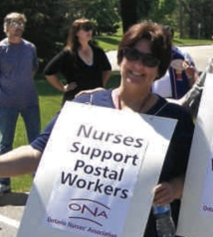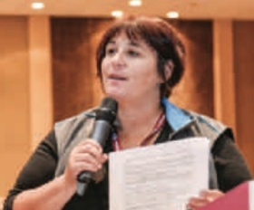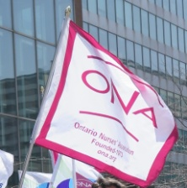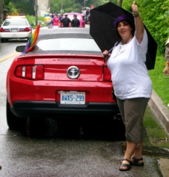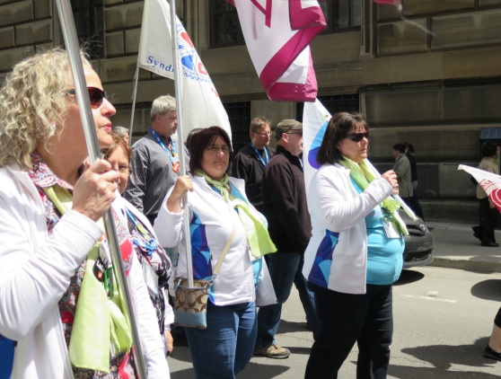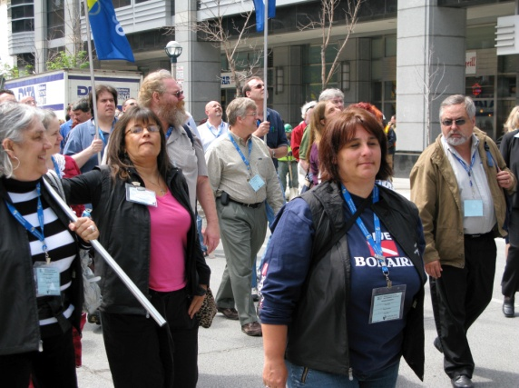

**Transparency**

I will … bring a new level of transparency to respect members and the dues they pay to the Union.

**economic welfare**

I will … push for improved working conditions and wage increases that value our worth.

Marching in support of Public Services and for the economic welfare of ONA members.

Talking to members to engage them in the union.

Supporting Public Services to create support for ONA.

**Our voices heard**

I will … work diligently with the public, politicians and employers to understand and recognize our values and hear our voices.

**A proud Membership**

I will … raise ONA’s profile to instill pride in our members; engage all to be part of "*our* Union".

**ValuING Diversity**

I will … value ONA's diversity and ensure we develop a strong team by mentoring and giving all members the opportunity to take on leadership roles.

**RN for 30+ years**

For the last 30 years, I have gained a wide range of nursing experience, in hospital nursing positions and, more recently, in the community with a CCAC.

**Union Leader**

I have extensive experience working with the union, as Grievance Chair, Negotiations, Bargaining Unit President, Local Coordinator and, for the past 11 years, as Vice President Region 4 and Local Finance.

**Passionate and Hardworking**

I pride myself on honesty and transparency. My focus is on improving working conditions, wages and benefits of our dedicated membership. I am committed to raising the profile of all healthcare workers to allow us to be recognized for the invaluable service we provide and the dedication we show to patients in Ontario.

I strongly believe it is important to continue to challenge the status quo and effect change in our Union.

**Respected. Strong. United.**

I believe in the

Ontario Nurses’ Association

as a strong and valued Union - *Respected. Strong. United.*

ONA is committed to people

who care for people.

**Who am I?**

**My Vision for the Future**

**….around the province and where you work.**

Strong supporter of diversity; seen here as an annual attendee at the Pride Parades.