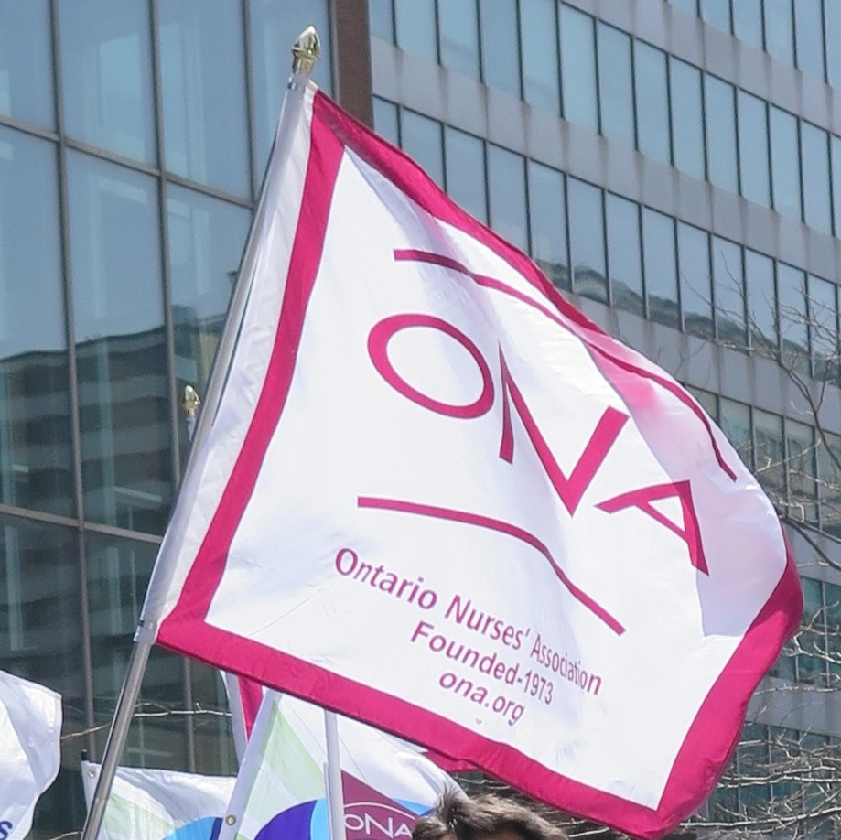

Vote on Nov 1st



Dianne Leclair

For President

A President for change!

Working hard with leaders and members towards a common goal.

Direct: 416-964-1979, ext. 7782

Toll Free: 1-877-839-6245, ext. 7782

[Email: ElectDianneLeclair@gmail.com](mailto:ElectDianneLeclair@gmail.com?subject=)

[Web Page: electdianneleclair.weebly.com](http://electdianneleclair.weebly.com/)

ONA’s Future:

ValuING Diversity

CREATING AN Effective Team

ENCOURAGING

New Ideas

W